Project Proposal

Group 2

Jackson, Alonzo, Nolan, Emanuel

* It will be a general trivia website where quizzes will provide prizes
* This website will contain a database for trivia questions and potential prizes for participants to win.
* The website will be built in HTML/CSS/Javascript.
* There will be SQL databases integrated into the website for an array of prizes and questions.
* The website will be hosted on 00Webhosting.
* We will use MS Project to track the project and to produce gantt charts.
* We will use GitHub for our code repository and share code.

Jackson- assigned database and sql work 5/21

Alonzo- assigned HTML code and website front end work 5/21

Nolan- assigned project detailing and documentation 5/21

Emanuel- assigned social media management and some document work 5/28

Tasks for next Milestone

* Completion of website code - Alonzo, Jackson
* Updating database table formats as needed - Jackson
* Updating project documents - Nolan
* Managing social medias and miscellaneous document work - Emanuel

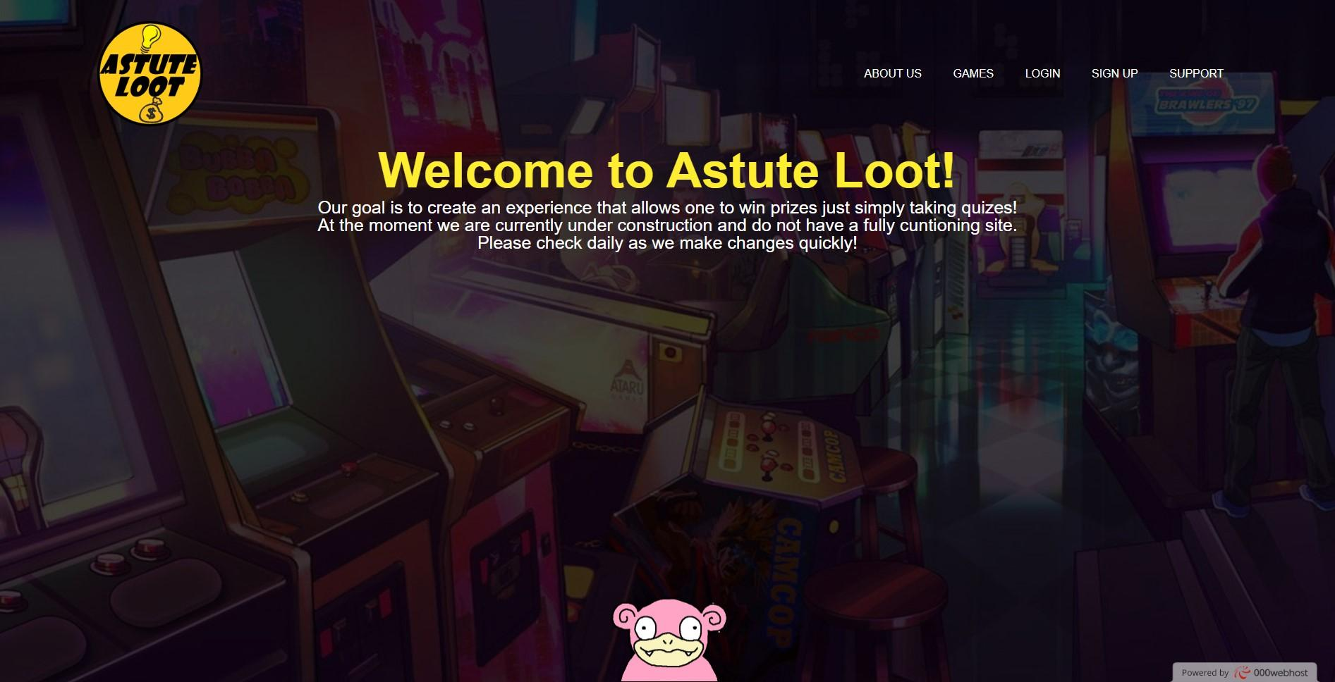

Emanuel- assigned gantt chart production and video production 5/26

Nolan- assigned graphic work and project manager role 5/21